**Project Proposal**

**LEAVE MANAGEMENT WEB APPLICATION**

**Aira Mae Ogaco**

**x21189510**

**x21189510@student.ncirl.ie**

**Higher Diploma in Science in Computing**

**10/02/2024**

**Background**

This project aims to explore the creation of a Leave Management System as a Web Application, providing companies and businesses with automated and efficient employee leave tracking for enhanced efficiency and improved communication. The inspiration behind this project comes from first-hand experience of working in companies where employee leave tracking is reliant on paper forms, spreadsheets or complicated and time consuming automated tracking.

There are many benefits to creating a Leave Management System (LMS) which will be highlighted throughout this proposal. More and more companies have started to integrate automated LMS to allow human resources teams to configure their company’s leave policies in order to have consistency and efficiency. LMS manages the different types and amount of leaves for employees, as well as employee availability.

One of the main advantages of an LMS is providing automation for the whole leave request process. The traditional way of tracking involves a lot of manual labour which is very time-consuming and is prone to human errors. Employees may face difficulties in tracking their leaves and understanding the company leave policies. By automating the whole process, this system will save more time for employees and management teams. It will also allow employees to easily create a request for leave, access their balances and view the status of their leave requests, ultimately empowering employees to manage their own leaves. With the traditional way of tracking, manual balance calculations may also cause error in leave balances and loss of employee leaves. Having automated leave balance calculations also helps reduce the risk of errors and provides improved accuracy and compliance.

Another advantage of LMS web applications is providing easy access for all users. Employees can easily submit requests, view their leave balances whilst managers are able to efficiently review any requests for approval. An effective LMS web application should offer real-time visual calendars that are available to users containing information on employee availability and leaves. A LMS web application can also address any communication gaps that a manual tracking has through providing automated email and notifications to keep employees and management teams up-to-date.

The manual leave tracking method lacks security, putting employee information at risk, in which the LMS web application is able to address. The LMS web application aims to incorporate security features that include encrypted data storage and role-based access controls for enhanced security and confidentiality so that only authorised personnel are able to access employee information when required.

Another challenging aspect of the traditional leave management system is analysing data and decision making. With the help of the LMS web application proposed, reporting and analytics features can allow companies to extract and analyse any historical leave data, leave trends and patterns to help with effective and strategic resource allocation and workforce planning.

The target audience for this project include various stakeholders within an organisation. The LMS web application caters to the needs of the different users involved in the leave management process. The main users involved are the employees, employers, human resources, IT support teams and administrators. This project aims to provide a user-centric web application that considers the specific needs of the target audience. The LMS web application will be designed to allow for adaptability and scalability in order to accommodate numerous users, changes in company leave policies and structures along with providing long-term effectiveness.

**Objectives**

This section of the project proposal will outline the key objectives involved in creating a Leave Management System as a web application. The list of key objectives are as follows:

* Submission of leave requests:
  + Users should be able to submit their leave requests through the system
  + Users should be able to select the type of leave for their requests such as annual leave, sick leave, paid/ unpaid leave, parental leave, etc. and provide details such as start and end date, reason, comments and attachments if required
* User authentication and authorisation:
  + To define the different types of user roles, such as employee, human resources/ employer, IT team, etc., and enable the appropriate permissions
  + To implement a user authentication system and only grant access to the authorised personnel (requirement for username, password, etc.)
* Approval of leave requests and notification system:
  + To create and design a workflow for approving leave requests catered to human resources/ employers
  + Enable notifications through email or in-app alerts when leave requests have been actioned, status of any leave requests, leave balances reaching a threshold, any upcoming leaves
  + To allow companies to customise leave policies in accordance to their rules and regulations
* Leave balances tracking:
  + To implement a system that allow employees to track and view their leave balances and allow human resources/ managers to view it for each employees
  + To implement a system that will automatically update the leave balances whenever a request has been actioned
* Real time calendar integration:
  + Users should be able to view their individual schedules or the team’s schedules
  + Uses should be able to view approved leaves and the different types of leave in the calendar
* User-friendly interface:
  + To design a user-friendly interface for enhanced user experience and perform tests to ensure functionality and usability are working as intended
* Data security and compliance:
  + To implement security measures with confidential employee information and ensure compliance with relevant data protection and regulations
* Data analytics and reporting:
  + To implement a system that allows for audit trail of leave approvals
  + To implement a system that can generate reports regarding leave trends and patterns and any relevant historical data whenever required for leave approval decision making
* QA testing and debugging:
  + To perform regular testing to ensure the web application’s functionality and reliability
  + To create a plan for a comprehensive testing and debugging to identify any issues
* Adaptability and scalability:
  + To design a system that will allow for any changes in company regulations, numbers of users and numerous amount of requests
* Mobile responsiveness:
  + To ensure the web application is accessible and responsive in mobile devices and tablets
  + This objective is optional and to be implemented if given the time

**Technical Approach**

In order to develop a leave management web application, a well structured technical approach must be involved and the key stages include research, literature review, requirements capture, system architecture and technology stack, implementation and more. This section of the proposal will highlight the key stages that will be followed throughout the development of the web application.

Research and literature review is a key initial stage in developing a leave management web application. Conducting research on existing leave management systems and web applications along with HR softwares, existing and best practices and any other technologies is crucial is understanding how to develop an effective LMS web application. Identifying implementation challenges, LMS web application trends, existing features can help with innovation and creating an effective and efficient system. This will be researched through case studies, academic literature and existing web applications.

The project requirements and documentation will be captured through the use of user stories, use cases and system requirements specifications. The project scope, web application functionalities and features will be identified based on company needs. Features will be prioritised based on its importance and feasibility.

The overall system architecture will consider effectiveness, security and scalability. React JS is to be implemented as the front-end framework, Node.js will be used for the back-end framework and MySQL will be used for the database technology. Git will also be used for deployment and to manage any changes to the code and collaborate with other developers in the future.

**Special resources required**

The ReactJS framework will be learned during personal time as this framework was not covered in the course and will act as an additional resource to be used for this project. Additionally, learning to link the back-end, front-end and database workflows will be learned during this project as it was not previously covered in the course.

**Project Plan**

The following gantt chart outlines the stages for the development of this project. This gantt chart is currently work in progress and will be updated throughout the duration of the project.

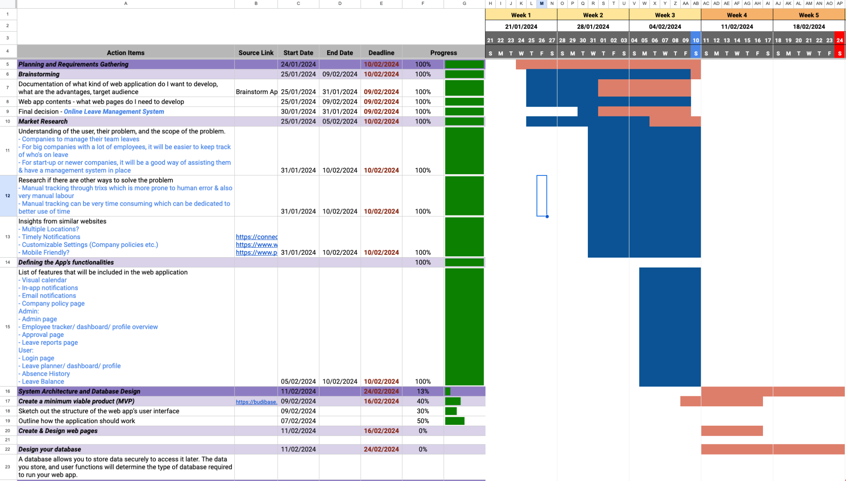

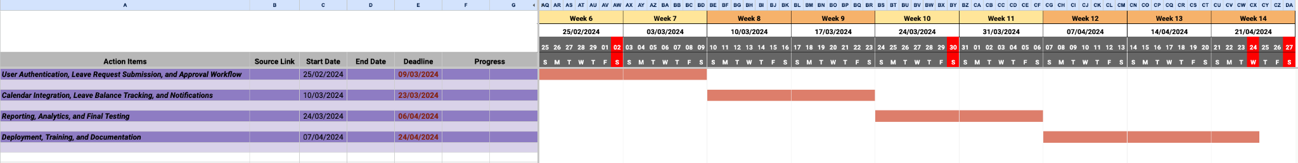

**Evaluation**

The LMS web application will be evaluated through various testing which include systems tests, user acceptance testing, and integration tests. Through systems and performance tests, the individual components of the system will be tested to ensure functionality, responsiveness, scalability and performance. The tests will be carried out by using real life scenarios to identify and address any potential issues. By performing integration testing, the compatibility and interaction between the different components in the system will be reviewed. This will ensure that both the back-end and front-end workflows will communicate and work seamlessly together. User acceptance testing will also be performed to ensure the specific needs and requirements of the end-user are addressed and implemented. In order to evaluate the user interface, it is crucial to conduct usability testing along with accessibility testing to ensure that users with disabilities are able to easily access and use the web application. Through the various testing methods outlined in this section, the effectiveness of the leave management web application will be assessed from the technical and end-user perspective in order to provide a successful web application.



**Aira Mae Ogaco**

**10.02.2024**

Signature of student and date